Updating the Polar Decomposition
Philip Wallstedt 26jul08
In solid mechanics computer simulation algorithms we may advance the deformation gradient F forward by using its rate, which is the product of the velocity gradient L and F:
$\overset{˙}{F}=\text{LF}$ (1)
However, the deformation gradient F can be decomposed into the rotation tensor R and the right stretch tensor U:
$F=\text{RU}$ (2)
We conjecture that some computational advantage could be gained by advancing R and U separately through time so that polar decomposition does not have to be drawn from F via eigenvalues and square roots or from an iterative process. In order to make this work we need expressions for the rates of R and U. We propose the following rates:
$\overset{˙}{R}=\text{WR}$ $\overset{˙}{U}=R^{T}\text{DRU}$ (3)
and we spend the remainder of this write-up justifying them. These rates may be well known, but they were not discussed in texts available to the author. Alternatively, they may be wrong or limited in some way, but the development and testing below is meant to bolster the case that the rates are correct and useful in computer codes.
We accept the notation of Mase and Mase throughout, and we note that:
$I=R^{T}R={\text{RR}}^{T}$ $U^{2}=C=F^{T}F$. (4)
We will use the additive decomposition of the velocity gradient:
$L=D+W$ $D=\frac{1}{2}\left(L+L^{T}\right)$ $W=\frac{1}{2}\left(L−L^{T}\right)$ (5)
The rate of C is presented, and decomposed:
$\overset{˙}{C}=2F^{T}\text{DF}=2U^{T}R^{T}\text{DRU}$ (6)
We find the rate of $U^{2}$ or $U^{T}U$ via the product rule and note that $U^{T}=U$:
$\overset{}{\left(U^{T}U\right)}={\overset{˙}{U}}^{T}U+U^{T}\overset{˙}{U}=2U^{T}\overset{˙}{U}$ (7)
We equate (6) with (7):
$2U^{T}R^{T}\text{DRU}=2U^{T}\overset{˙}{U}$ (8)
At this point it seems clear $\overset{˙}{U}=R^{T}\text{DRU}$ as in (3).
We continue by decomposing the rate of change of F:
$\overset{˙}{F}=\text{LF}=(D+W)\text{RU}$ (9)
Alternatively, we take the rate of the decomposition via the product rule:
$\overset{˙}{F}=\overset{}{\left(\text{RU}\right)}=\overset{˙}{R}U+R\overset{˙}{U}$ (10)
Finally we equate (9) with (10):
$\overset{˙}{R}U+R\overset{˙}{U}=\text{WRU}+\text{DRU}$ (11)
Now we substitute in the rate of U:
$\overset{˙}{R}U+{\text{RR}}^{T}\text{DRU}=\text{WRU}+\text{DRU}$ (12)
Noting again that $I=R^{T}R={\text{RR}}^{T}$ we cancel equivalent terms and end up with:
$\overset{˙}{R}U=\text{WRU}$ (13)
This indicates that the rate of R is $\overset{˙}{R}=\text{WR}$ as written in (3).
The solid mechanics algorithm GIMP is used to solve a manufactured solution that involves significant amounts of non-linear rotation, deformation, and shear, as indicated in the two sample figures, below (colored by the Jacobian). R and U are updated through time, rather than F.
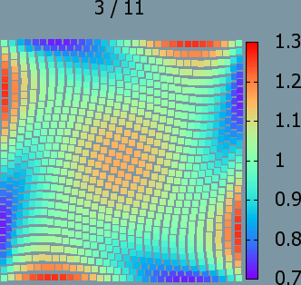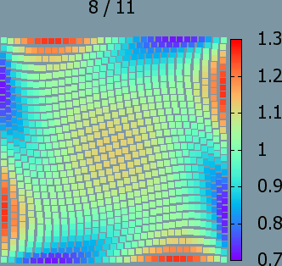
The L-infinity error for this problem is reduced at a second order rate and appears to be equivalent to solving the problem in the usual manner (updating the deformation gradient F).
