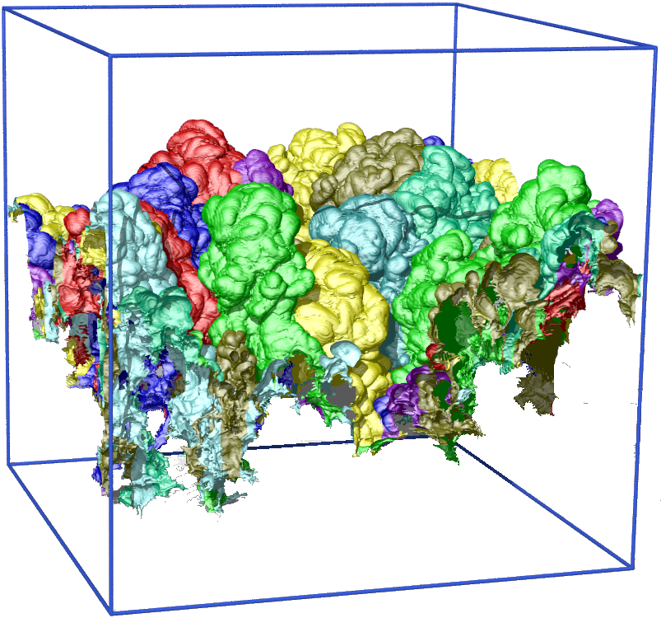
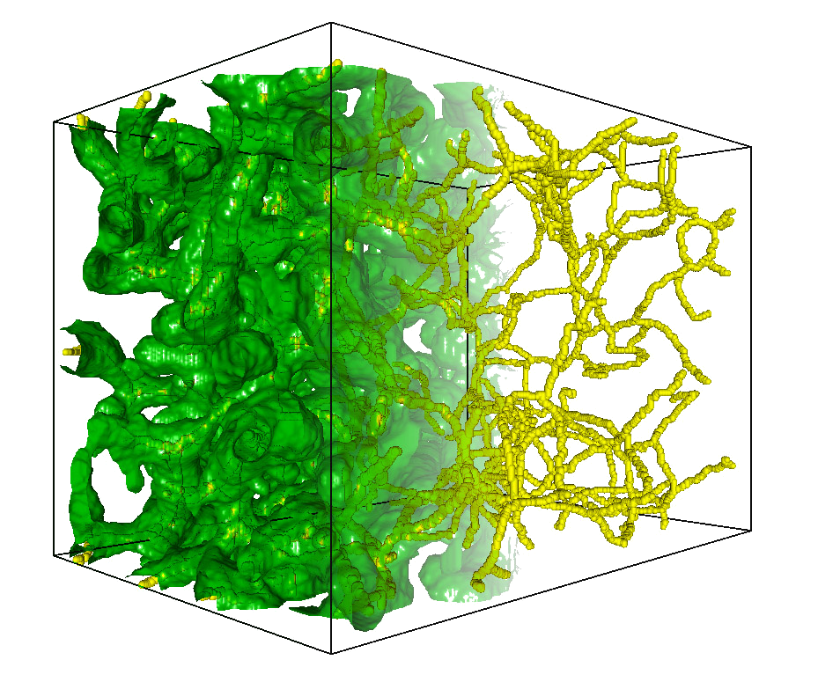
Big Data Analytics
for Science Discovery
hydrodynamic
instability
porous
medium

Valerio Pascucci
Director, Center for Extreme Data Management Analysis and Visualization (CEDMAV)
Associate Director, Scientific Computing and Imaging Institute
Professor, School of Computing, University of Utah
Laboratory Fellow, Pacific Northwest National Laboratory
CTO, ViSUS Inc. (visus.us)

ABSTRACT
Advanced techniques for analyzing and understanding Big Data models are a crucial ingredient for the success of any supercomputing center and data intensive scientific investigation. Such techniques involve a number of major challenges such as developing scalable algorithms that run efficiently on the simulation data generated on the largest supercomputers in the world or incorporating robust methods are provably correct and complete in their extraction of features from the data.
In this talk, I will present the application of a discrete topological framework for the representation and analysis of large scale scientific data. Due to the combinatorial nature of this framework, we can implement the core constructs of Morse theory without the approximations and instabilities of classical numerical techniques. The inherent robustness of the combinatorial algorithms allows us to address the high complexity of the feature extraction problem for high resolution scientific data.
Our approach has enabled the successful quantitative analysis for several massively parallel simulations including the study turbulent hydrodynamic instabilities, porous material under stress and failure, the energy transport of eddies in ocean data used for climate modeling, and lifted flames that lead to clean energy production.
During the talk, I will provide a live demonstration of some software tools for topological analysis of large scale scientific data and discuss the evolution of the organization of the project, highlighting key aspects that enabled us to successfully deploy this new family of tools to scientists in several disciplines.

BIOGRAPHY
Valerio Pascucci is the funding Director, Center for Extreme Data Management Analysis and Visualization (CEDMAV), recently established as a permanent organization at the University of Utah in collaboration with the Pacific Northwest National Laboratory. Valerio is also an Associate Director, Scientific Computing and Imaging Institute, a Professor, School of Computing, University of Utah, and a Laboratory Fellow, of PNNL. Before joining the University of Utah, Valerio was the Data Analysis Group Leader of the Center for Applied Scientific Computing at Lawrence Livermore National Laboratory, and Adjunct Professor of Computer Science at the University of California Davis. Valerio's research interests include Big Data management and analytics, progressive multi-resolution techniques in scientific visualization, discrete topology, geometric compression, computer graphics, computational geometry, geometric programming, and solid modeling. Valerio is the coauthor of more than one hundred refereed journal and conference papers and has been an Associate Editor of the IEEE Transactions on Visualization and Computer Graphics.

