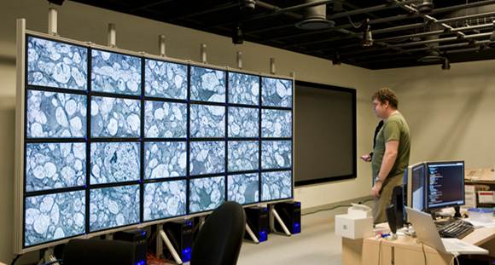
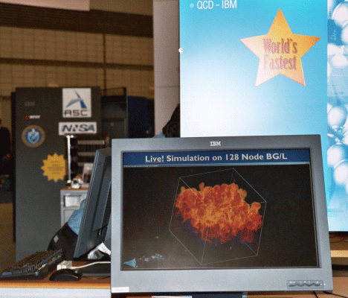
Multi-Resolution Streams of Big Scientific Data: Scaling Visualization Tools from
Handheld Devices to In-Situ Processing
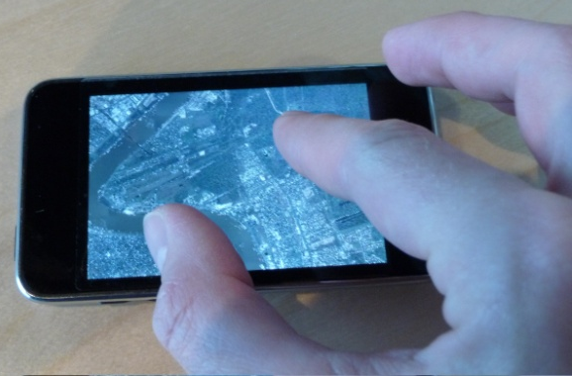

Valerio Pascucci
Director, Center for Extreme Data Management Analysis and Visualization (CEDMAV)
Associate Director, Scientific Computing and Imaging Institute
Professor, School of Computing, University of Utah
Laboratory Fellow, Pacific Northwest National Laboratory
CTO, ViSUS Inc. (visus.us)

ABSTRACT
Effective use of data management techniques for massive scientific data is a crucial ingredient for the success of any supercomputing center and data intensive scientific investigation. Developing such techniques involves a number of major challenges such as the real-time management of massive data, or the quantitative analysis of scientific features of unprecedented complexity. Addressing these challenges requires interdisciplinary research in diverse topics including the mathematical foundations of data representations, the design of robust, efficient algorithms, and the integration with relevant applications in physics, biology, or medicine.
In this talk, I will present a scalable approach for processing large scale scientific data with high performance selective queries on multiple terabytes of raw data. The combination of this data model with progressive streaming techniques allows achieving interactive processing rates on a variety of computing devices ranging from handheld devices like an iPhone, to simple workstations, to the I/O of parallel supercomputers. I will demonstrate how our system has enabled the real time streaming of massive combustion simulations from DOE platforms such as Hopper2 at LBNL and Intrepid at ANL.
During the talk, I will provide a live demonstration of the effectiveness of some software tools developed in this effort and discuss the deployment strategies in an increasing heterogeneous computing environment.

BIOGRAPHY
Valerio Pascucci is the funding Director, Center for Extreme Data Management Analysis and Visualization (CEDMAV), recently established as a permanent organization at the University of Utah in collaboration with the Pacific Northwest National Laboratory. Valerio is also an Associate Director, Scientific Computing and Imaging Institute, a Professor, School of Computing, University of Utah, and a Laboratory Fellow, of PNNL. Before joining the University of Utah, Valerio was the Data Analysis Group Leader of the Center for Applied Scientific Computing at Lawrence Livermore National Laboratory, and Adjunct Professor of Computer Science at the University of California Davis. Valerio's research interests include Big Data management and analytics, progressive multi-resolution techniques in scientific visualization, discrete topology, geometric compression, computer graphics, computational geometry, geometric programming, and solid modeling. Valerio is the coauthor of more than one hundred refereed journal and conference papers and has been an Associate Editor of the IEEE Transactions on Visualization and Computer Graphics.

