EXPERIMENT HUNGRY FUNGUS

Roberto Pascucci
For this experiment I used 1 package of powdered yeast, some sugar, a glass of soda, a measuring spoon, a cup, and a balloon.
I mixed the yeast with the sugar in one cup of warm water and I poured the solution in a bottle containing one glass of soda. I added another cup of warm water to the bottle and I placed a balloon over the mouth of the bottle.
Then I placed the bottled in a dark a warm place for 3 days.
When I mixed the powdered yeast with the sugar into the water.

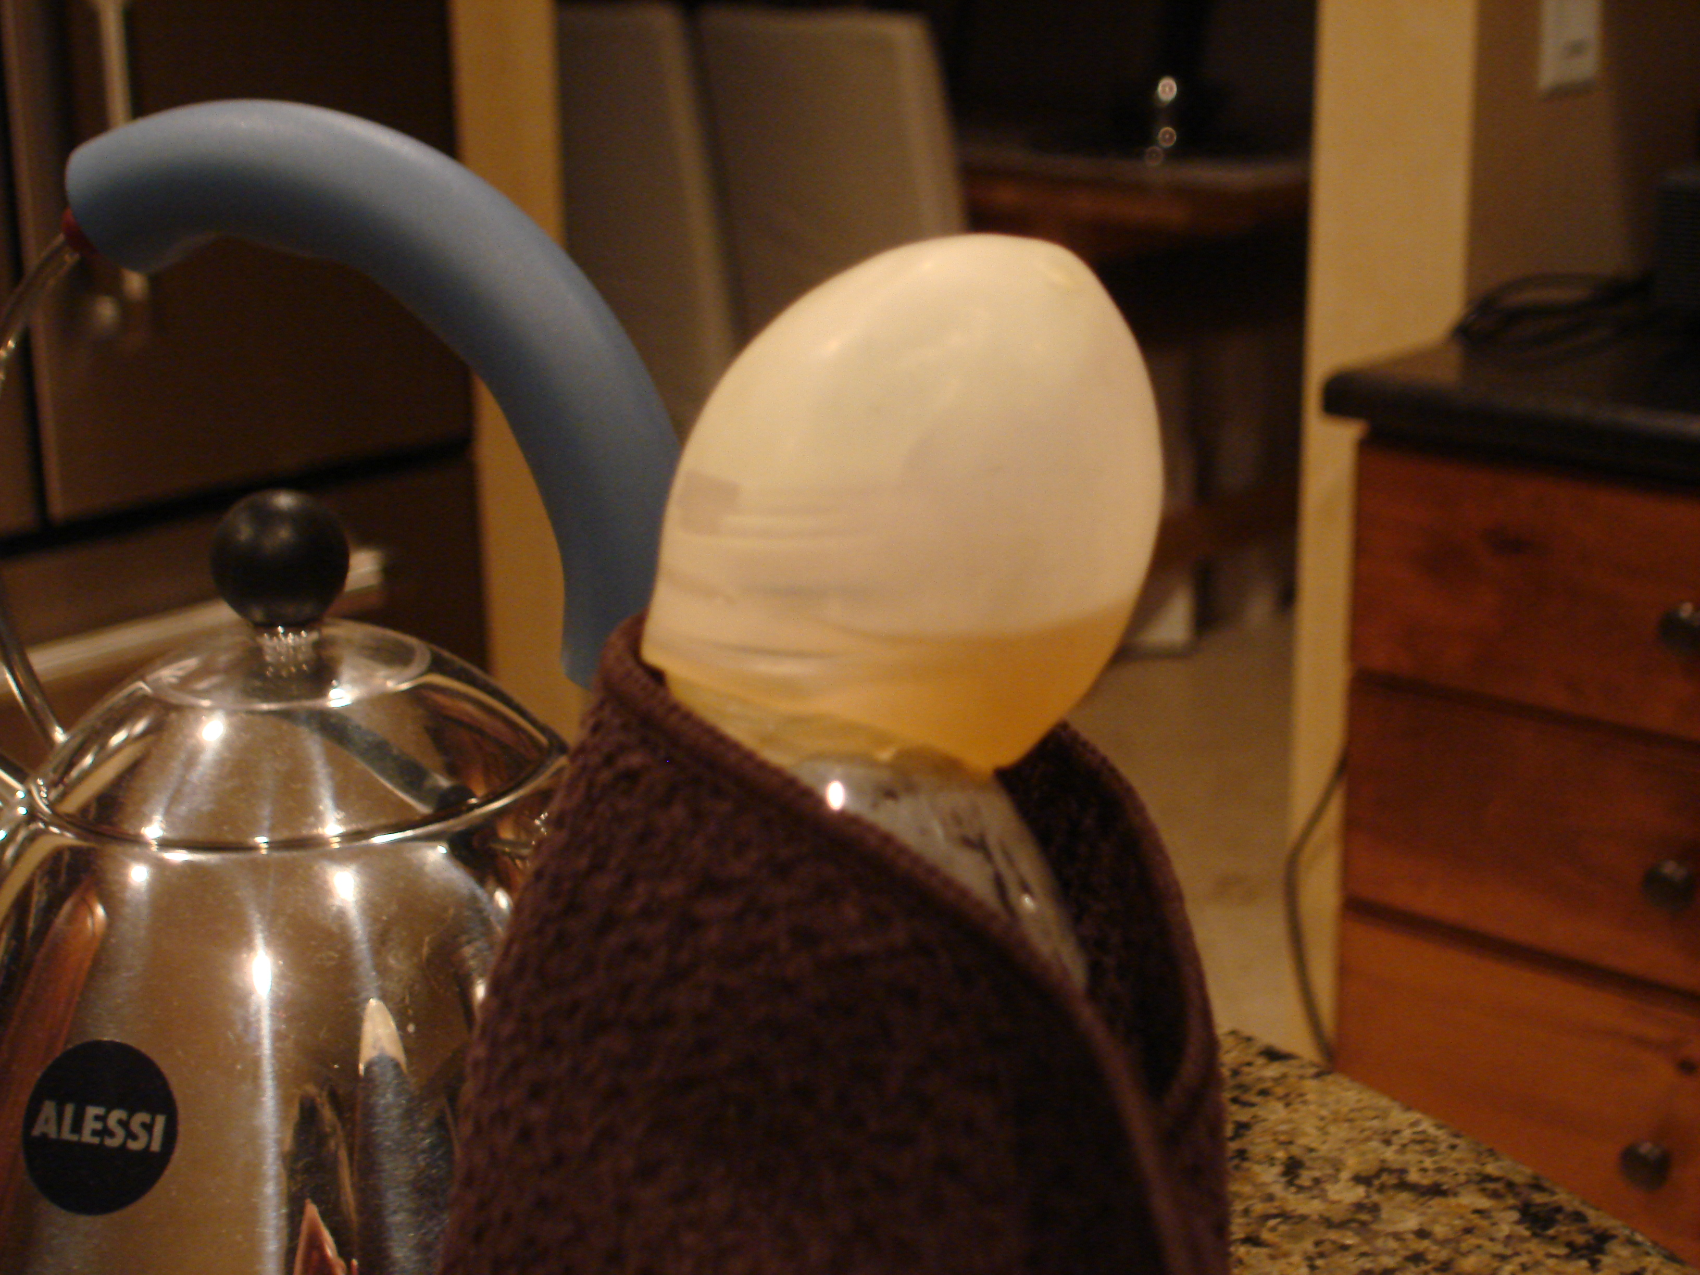
Growth of the baloon due to the reaction of the yeast producing gas.

