Visualization, Annotation, and Exploration of Three Dimensional Datasets Using an Existing 3D Rendering System

S. Janna Balling1

1Department of Bioengineering, University of Utah, Salt Lake City, UT

AbstractThe demand for user-friendly tools to view three dimensional (3D) volumes and create original annotations in real-time has increased with the popularity of 3D volume exploration. This project developed a tool, Annot3D, that allows users to easily compose xml text instructions to visualize original Computed Tomography (CT) volume data sets, add useful and simple annotations, and explore the data in real-time. Annot3D was composed of many modules designed to interact with an existing, complex rendering system called the Visualization Tool Kit (VTK).

VTK is a collection of many complex functions including those to visualize 3D datasets, render 3D shapes and text to use as annotations, and adjust the viewing angle of the rendered images. The resulting images are displayed in the VTK interaction window where users can update the scene using additional functions or mouse movements.

VTK functions were packaged using the Tcl programming language into Tcl procedures which condensed the complex VTK function calls into simple command line calls. Procedures for annotations included spheres, cubes, lines, text, a PointPicker (to display coordinates of the dataset), and dataset clipping with a plane, sphere, or cube. Procedures for interactions with the scene were composed to allow users to rotate, translate, scale, or produce two dimensional (2D) pictures of the interactions window.

A text parser was used to interpret the xml text instructions created by the user. The xml code was designed to correspond with each Tcl procedure in Annot3D and provides the interface for users to run Annot3D.

The TclHttpd web server was used to optionally extend Annot3D to interact through a web page. It allows multiple users to access and use one copy of the software from any web browser. In order to run commands from multiple users, a Client ID was integrated into the Tcl procedures to keep track of the multiple scenes.

Annot3D was demonstrated to a class of anatomy students by their professor and a survey was taken to determine the software’s effectiveness. Results confirmed the usefulness of the features of Annot3D and provided a positive outlook towards future use of the software.

Through the software modules and their implementation, Annot3D was able to provide a simple tool for visualizing, annotating, and interacting with original 3D datasets.

Keywords3D rendering, Annotations, Software design

Introduction

As three dimensional (3D) volume exploration has become increasingly popular, the demand for user-friendly tools to view 3D volumes and create original annotations in real-time has increased. Current 3D annotation software, such as VoxelMan9, Digital Anatomist2, and Anatomy Browser1, does not allow the use of original datasets and/or prevents real-time 3D exploration. Presently, interactive 3D volume viewing can only be accomplished through real-time rendering software which requires complex computer programming knowledge to use.
Creating a user-friendly tool that provides original 3D volume viewing, annotating, and real-time exploration presents the following design challenges.
- The tool needs to render volume datasets from several popular acquisition techniques, such as Computed Tomography (CT) and Magnetic Resonance Imaging (MRI) data.
- Annotations should be useful in labeling, highlighting, and exploring the data. Annotations such as spheres, text, and lines should be three dimensional so that users can view the annotations from any angle.
- Viewing of the volume should be controlled by the user, allowing the user to see any perspective of the volume.
A solution to these design challenges is using an existing software package, the Visualization Tool Kit (VTK),8 to render and manipulate the scene. A more user-friendly authoring and exploration tool would then be created to interact with the complex VTK software.
This project will create a software tool, named Annot3D, to allow users to easily compose text instructions to
- view 3D volume sets
- create annotations
- interact with the scene in real-time
Annot3D will interpret these instructions and use VTK software to render the requested scene. To provide availability to most users Annot3D will be developed and tested on both Windows and Linux2 systems. While the text instructions will be easy for users to compose, Annot3D will provide the means for interacting with a more user-friendly interface in future development.

METHODS

Annot3D is composed of many modules that interact with VTK according to Figure 1. By organizing Annot3D into modules, the software can be easily developed, updated, and maintained. Each module was chosen with the overall software goals in mind to perform a specific task as explained below.

Figure 1. The module composition of Annot3D provides organization for software development, maintenance, and excitability.

Visualization Tool Kit

The VTK rendering system is a collection of many complex functions. Among these, there are functions for visualizing 3D datasets in many formats. VTK functions also allow generation of 3D shapes and text that can be used as annotations. Mouse movements in the VTK interaction window or VTK interaction functions can be used to adjust the viewing angle of the rendered image.

Tcl Procedures

Functions in the VTK rendering system can be called using the Tcl6 programming language. This language also allows users to create and execute their own functions, or Tcl procedures. The VTK functions necessary for rendering volume datasets, rendering objects that would best serve as annotations, and performing useful window interactions were determined. Then those VTK functions were packaged into Tcl procedures to provide for the basic requirements of Annot3D.

Xml Code and Xml Parser

Xml code was used as the language for the user to compose text instructions for visualizing, annotating and interacting with the scene. Xml tags were created to represent each Tcl procedure. Tags for variable specifications were chosen so that the user could easily understand the values to provide. For example, Figure 2 shows the xml code to create a dot annotation that is green, 30% opaque, 5 pixels in diameter, and located at the coordinate 133.5, 167.9, 33.32 in the scene.

<dot name="demodot" visibility="On">
<color>
<red>0</red>
<green>1</green>
<blue>0</blue>
</color>
<opacity>.30</opacity>
<radius>5</radius>
<center>
<x>133.5</x>
<y>167.9</y>
<z>33.32</z>
</center>
</dot>
Figure 2. Xml code can be used to create a dot annotation with the desired values for the color, opacity, radius, and center location variables.

A text parser was used to interpret the xml code and make calls to the corresponding Tcl procedures. It was also written as a collection of Tcl procedures. The main xml parser procedure receives the given xml code and sends it to the remaining parser procedures, which then run the appropriate Tcl procedures with the given variables.

Web Server

The TclHttpd web server7 was used to optionally extend Annot3D to interact through a web page rather than just the VTK interaction window. This web server allows web pages to be created using standard HTML3 tags as well as any Tcl procedures. By composing a web page to execute the Annot3D Tcl procedures, multiple users could access and use one copy of the software through any web browser. For example, teachers could install and run the web server, while their students would only need a web browser and a copy of the xml text instructions to run Annot3D through the teacher’s machine.

Results

The use of modules to design the Annot3D software proved effective in updating and maintaining the software. While each module presented individual challenges, by resolving these challenges, the package as a whole was completed and the overall goals of the project were met.

Visualization Tool Kit

When rendering Computed Tomography (CT) volume datasets from different sources, it was discovered that the data format is not always standard. As a result, a variety of VTK functions were used to visualize volume data.
A CT dataset of the human head included in the VTK software8 and CT mummy scans from the SCI Institute database5 were visualized using a VTK raw format reader. This format required simply the data specifications and file locations in order to be rendered.
Original CT scans of the scapula, humerus, and clavicle bones taken at the University Hospital5 were in a common Dicom format. These files required pre-processing to convert to a raw type of format. The raw type files were then rendered using a VTK isosurface generator.
The datasets from the University Hospital also included extraneous information for the interior of the bones that caused the interaction of the rendered image to be slow and inefficient. Additional VTK functions were used to convert the raw type files to datasets containing only the information for the outer shell of the bones. This data was then rendered with a VTK surface reader and was found to responded with a reasonable interaction speed.

Tcl Procedures

The use of Tcl Procedures to package the many VTK functions needed resulted in the ability to render each object by using a simple command line with the necessary variables, as shown in Figure 3. This also provided the xml parser with procedures requiring only the desired information (variables) for rendering each object.

Dataset visualizations.
The different VTK procedures needed to visualize different volume dataset types resulted in three different Tcl Procedures for rendering data.
- VolumeReader for raw data
- PointsReader for pre-processed Dicom data
- SurfaceViewer for condensed isosurface data
These procedures were found successful at rendering CT datasets. While these procedures should also be capable of rendering other common 3D datasets, such as MRI, further testing will be needed.
The interactivity speed of the datasets was found to decrease with the volume size. Greater interactivity was achieved by using the software on computers with more efficient processors and graphics cards.

global env
global IDname
set IDname $env(ClientID)
set renderer Renderer
set renderer $IDname$renderer
set source DotSource
set source $name$source
set mapper DotMapper
set mapper $IDname$name$mapper
set actor Actor
set actor $IDname$name$actor
vtkPolyDataMapper $mapper
$mapper SetInput [$source GetOutput]
vtkActor $actor
$actor SetMapper $mapper
$actor SetOrigin 0 0 0
$actor SetPosition $x $y $z
[$actor GetProperty] SetColor $r $g $b
[$actor GetProperty] SetOpacity $opacity
$renderer AddActor $actor
set renderObjects RenderObjects
set renderObjects $IDname$renderObjects
lappend env($renderObjects) $mapper $actor

renderDot name x y z r g b opacity

Figure 3. Tcl Procedures package the many, complex VTK function calls used to render a dot (top) into a single, simple command-line function with variables (bottom).

Annotations.
The sphere, cube, line, and text VTK objects, shown in Figure 4, were chosen for basic annotations. Applicable variables such as opacity, position, color, and rotation were provided in the Tcl procedures. These annotations allowed areas of the dataset to be highlighted to show points or regions of interest as shown in Figure 5. They were also designed to act as buttons to display other annotations. For example, a sphere can act as a button to display text when picked as shown in Figure 6. This was useful for including two dimensional (2D) annotations, like text, and for minimizing the clutter of displaying many annotations at once.
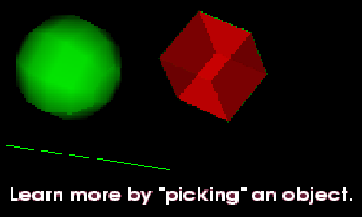
Figure 4. Basic annotations used in Annot3D include the sphere, cube, line, and text VTK objects.

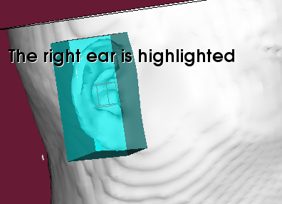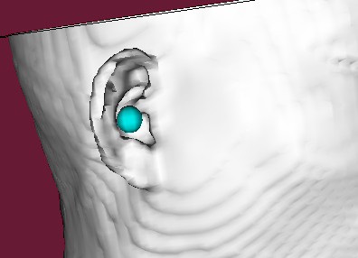
Figure 5. Annotation objects can be used to highlight a point (left) or region (right) of interest.

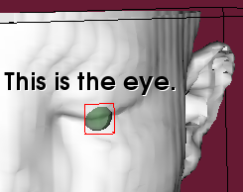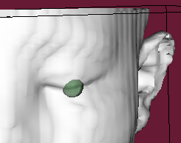
Figure 6. Annotation objects such as a sphere (left) can be used as a button to display other objects such as text (right).

A more adavanced annotation, the PointPicker, was included to displays the coordinates of the dataset when activated, as shown in Figure 7. This annotation proved useful in finding coordinates for authoring other annotations and exploring the visualized dataset.

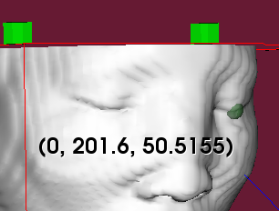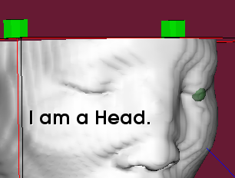
Figure 7. The PointPicker annotation allows users to switch between normal picking (left) and picking to display data coordinates (right).

Tcl procedures for clipping the dataset with a plane, sphere, or cube were also included in the annotations. These allow exploration of the inside of a dataset when the data is clipped away as shown in Figure 8 (left). It also provides a way to highlight a large area of the data by changing the color of the clipped area while leaving the original dataset visible as shown in Figure 8 (right).
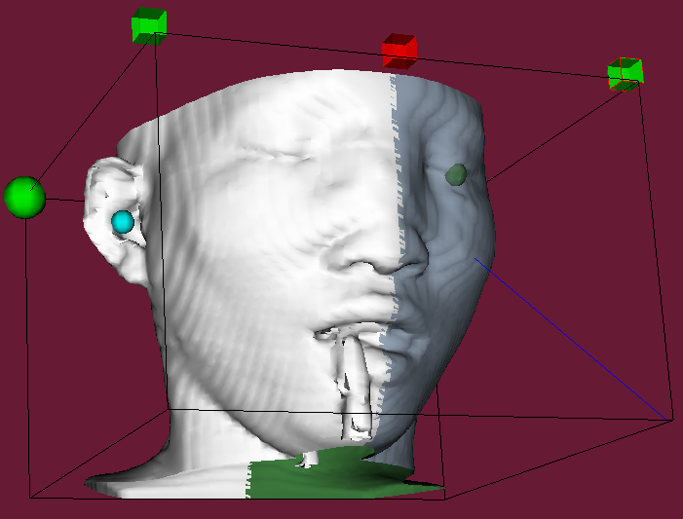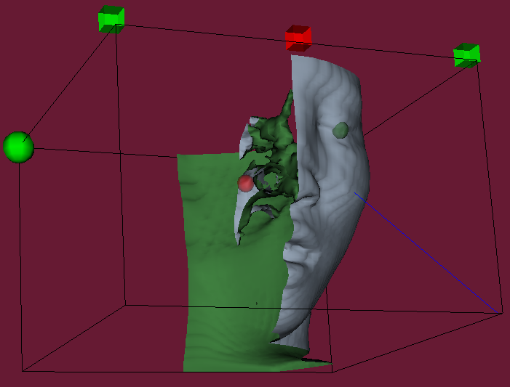
Figure 8. Clipping plane annotations can be used to explore the inside of a dataset (left) or highlight a large area of a dataset (right).

Interactions.
The Tcl procedures that control interactions include functions to rotate, translate, and scale the rendered scene. A procedure for picking objects was included to allow buttons to be selected by the user. Functions for producing 2D images of the VTK interaction window in .jpg or .png format were included to provide the user and/or the web server with an image of the rendered scene.

Xml Parser

The xml parser interpreted the xml code by scanning through the code to find the specific xml tags corresponding to the Tcl procedures. It then determined the following variable settings tags for that procedure and inserted them into the command line call to the procedure. By calling all the Tcl Procedures for visualizing, annotating, and interacting with the data, the desired scene was rendered in the VTK interaction window.
After the initial rendering, the scene could be explored in two ways. Additional xml code for interactions could be parsed and applied to update the VTK interaction window with the current view. Interactions could also be performed by mouse movements in the VTK interaction window.

Web Server

A web page was composed to run Annot3D on the TclHttpd web server. HTML tags were used to allow users to post xml code on the web page. This xml code was then passed to the Tcl xml parser procedures. A Tcl interaction procedure was then used to capture a 2D .png image of the resulting VTK interaction window. This image was then posted on the web page for the user to view. This same process was used to allow users to explore the data through updating the scene with xml code for interactions.
In order to run multiple user interface sessions on the same web server, the concept of a Client ID was established and integrated into the Tcl procedures. When rendering a scene, the user would generate a unique Client ID for that scene. When multiple users were interacting (through the interface tool) with the same web server, the Client ID was used to distinguish between xml text instructions from the different users and so direct Tcl procedure commands to separate scenes. The Client ID feature was not implemented to function when the TclHttpd web server was run on Linux machines due to caveats of the web server.
The resulting web page provided a more instructive environment for users to run Annot3D on their xml code. It also provided a simple means for implementing a more user-friendly interface to interact with Annot3D in future developments.

User Feedback

The Annot3D software was tested by a group of anatomy professors at the University of Utah who downloaded and used the software to create original models to demonstrate the anatomy and spatial relationships of three shoulder bones. The effectiveness of Annot3D features were then determined by a survey given to eleven medical students who participated in a demonstration from the anatomy professors.
The survey results, shown in Figure 9 (top), confirm that the features of Annot3D are useful, especially in an educational setting. While some features were more useful than others (see Figure 9 bottom), all features received high scores. Comments from the anatomy professors and students were positive towards future use of the software, especially if a more user-friendly interface is implemented.

Measurement | Average Survey Result  (scale from 1 to 10)
Overall effectiveness for learning anatomy | Somewhat useful (5)  to very useful (10)
Effectiveness of Annot3D vs. printed atlases and textbooks in learning the names of anatomical structures | Somewhat better (7)
Effectiveness of Annot3D vs. printed atlases and textbooks in terms of helping students to gain a mind’s eye view and learn spatial relationships | Significantly better (10)
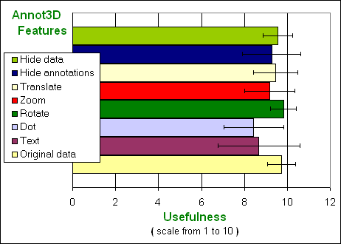Figure 9. Survey results show the effectiveness of Annot3D (top) and the usefulness of the Annot3D features (bottom).

Documentation and Availability

In order to uphold proper programming etiquette and to make the programming process less confusing, documentation of each Tcl Procedure’s function and use was created and maintained as a header in the function. Tcl Procedures were also organized by function into folders convenient for software distribution.
In accordance with the funding for this project, the Annot3D software was distributed as open source code via the internet. Complete documentation of the Annot3D software was created and maintained on the software webpage cited in Table 1. This webpage also includes information for downloading the software and an image gallery of software capabilities.

TABLE 1. URLs for software developed and used in this project.
Annot3D Home page
www.sci.utah.edu/~balling/Annot3D/
VTK Home Page
http://www.vtk.org/
Tcl Developer Site
http://www.tcl.tk/
HTML Tag List
http://www.webmaster.crevier.org/tags/index.html

Conclusions

The Annot3D software fulfilled the three major goals of this project. Users can easily compose xml text instructions without having complex computer programming knowledge. They can visualize original CT volume data sets and add useful, simple annotations. They can explore the data in real-time using either the mouse in the VTK interaction window or xml code for interaction commands. Annot3D can also be run through the TclHttpd web server, which provides the means for interacting with a more user-friendly interface in future development as well.
While Annot3D proved to be a useful tool for 3D exploration, there is still room for improvements in the future. A more user-friendly interface (similar to Microsoft® Paint) would get user instructions without the users having to create xml text. Faster computer processor speeds and more advanced graphics cards would allow large data sets (over 500 slices) to render faster and increase the interactivity rate. The data set size could also be reduced by additional VTK functions for data processing. Annot3D could be tested to run other types of common format data sets, such as MRI.

Acknowledgements

I would like to thank Jenny Simpson who was my partner in development of Annot3D. Thanks also to Dr. David Morton for his opinions and use of the software in his classroom and Kenneth Foreman for his help with obtaining CT data for the humerus, clavicle, and scapula. Funding for this project was provided by a grant from the National Science Foundation (grant#ACI-9619019 PI-Chris Johnson, Ph.D.).

References

¹Anatomy Browser: open-source copyright. 25 Jan 2004 <http://splweb.bwh.harvard.edu:8000/pages/papers/AnatomyBrowser/current/>.
²Digital Anatomist Interactive Atlas, University of Washington, 1997: 25 Jan 2004 <http://www9.biostr.washington.edu/ da.html>.
³HTML Tag List: open-source copyright 25 Jan 2004 <http://www.webmaster.crevier.org/tags/indes.html>. ⁴Linux Redhat Distibution: open-source copyright 25 Jan 2004 <http://www.redhat.com>.

⁵Scientific Computing and Imaging Institute, University of Utah. 30 Nov 2003 <http://www.sci.utah.edu>.s
⁶Tcl/Tk 8.3: open-source copyright. 25 Nov 2003 <http://dev.scriptics.com>.
⁷TclHttpd 3.4.2: open-source copyright. 25 Nov 2003 <http://www.tcl.tk/software/tclhttpd/>.
⁸Visualization Tool Kit 4.2: open-source copyright. 10 Oct 2003, <http://www.vtk.org>.
⁹Voxel man, Springer-Verlag Heidelberg New York, 2003: 25 Jan 2004 <http://www.uke.uni-hamburg.de/zentren/ experimentelle_medizin/informatik/forschung/vm/index.en.html>.

